**HEATHCARE ANALYSIS**

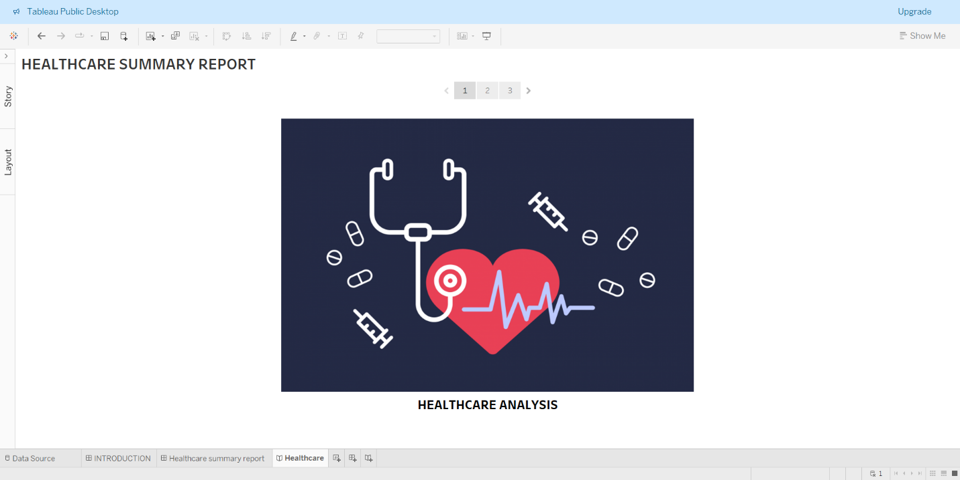

1. **Story board with project title and image**

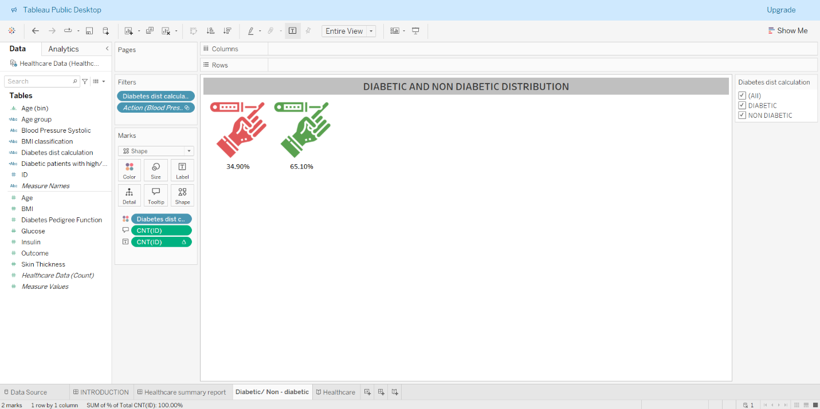

1. **View 1: Diabetic/non-diabetic distribution using Shapes**

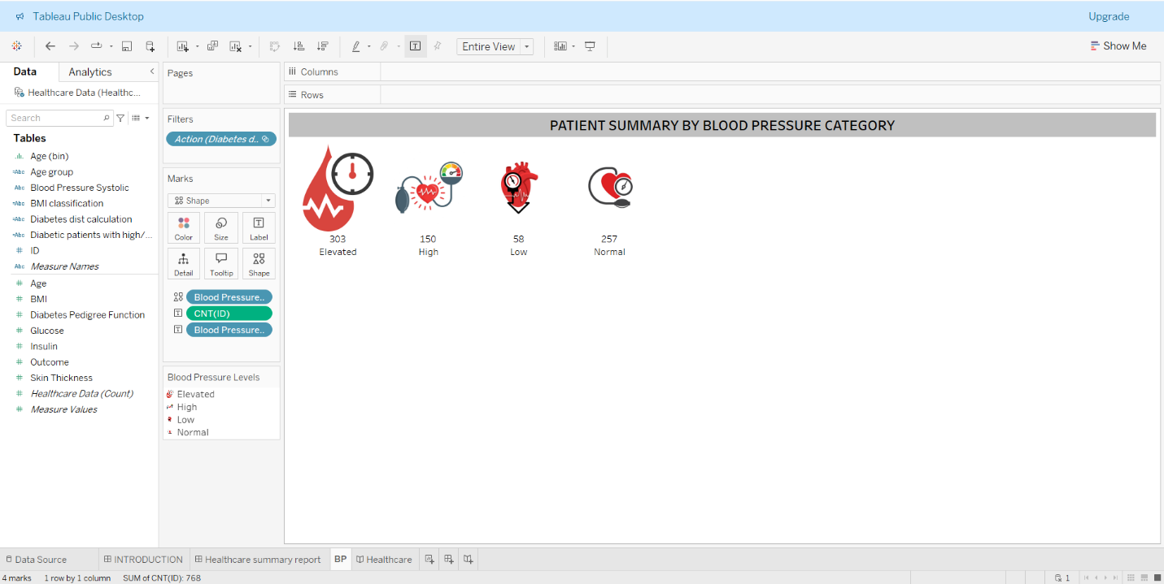

1. **View 2: Patient summary by Blood Pressure category**

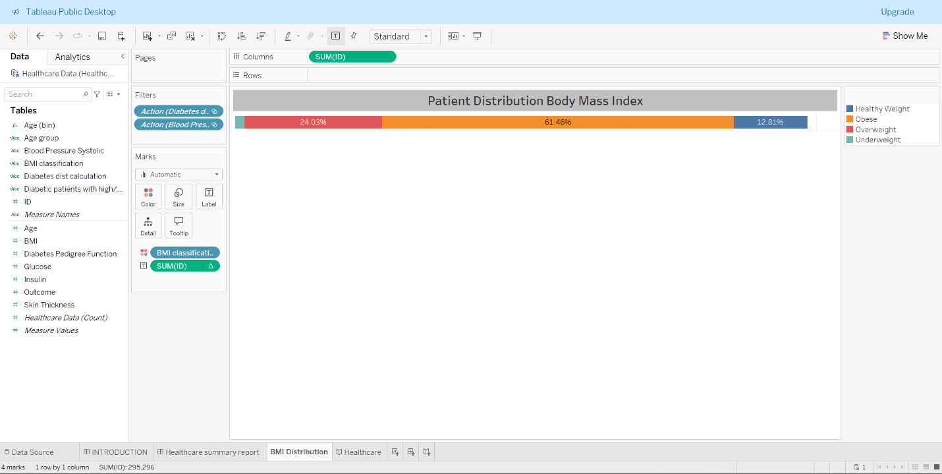

1. **View 3: Single Bar showing percent distribution of patients by BMI type**

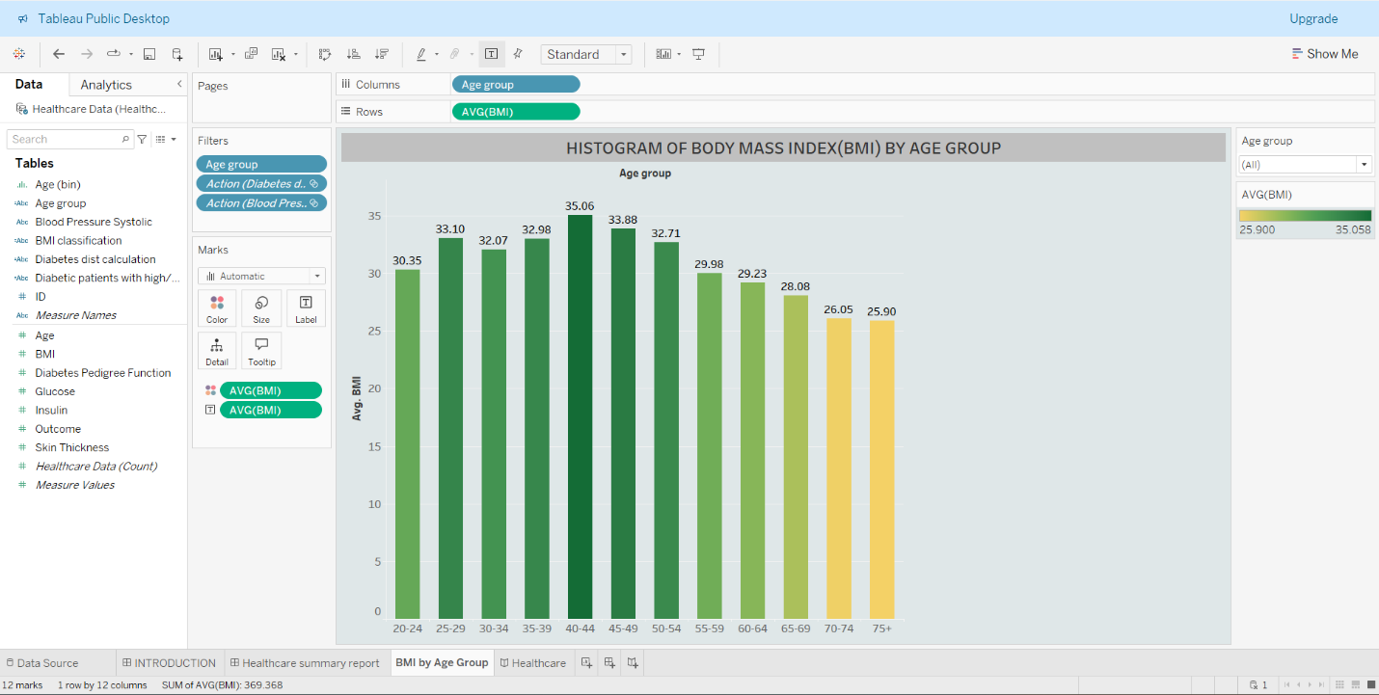

1. **View 4: Create a Histogram to show Body Mass Index (BMI) by Age Groups.**

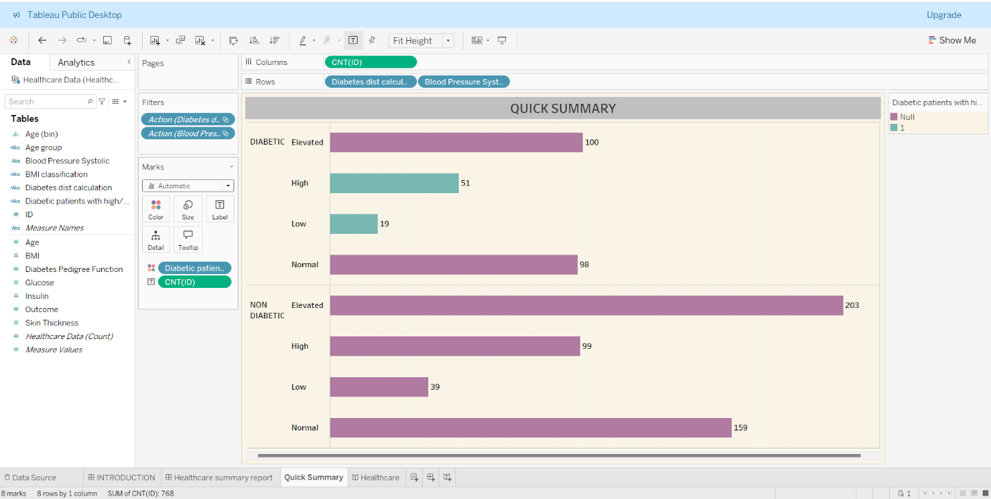

1. **View 5: Bar Chart showing Patient break down by Blood Pressure and Diabetes**

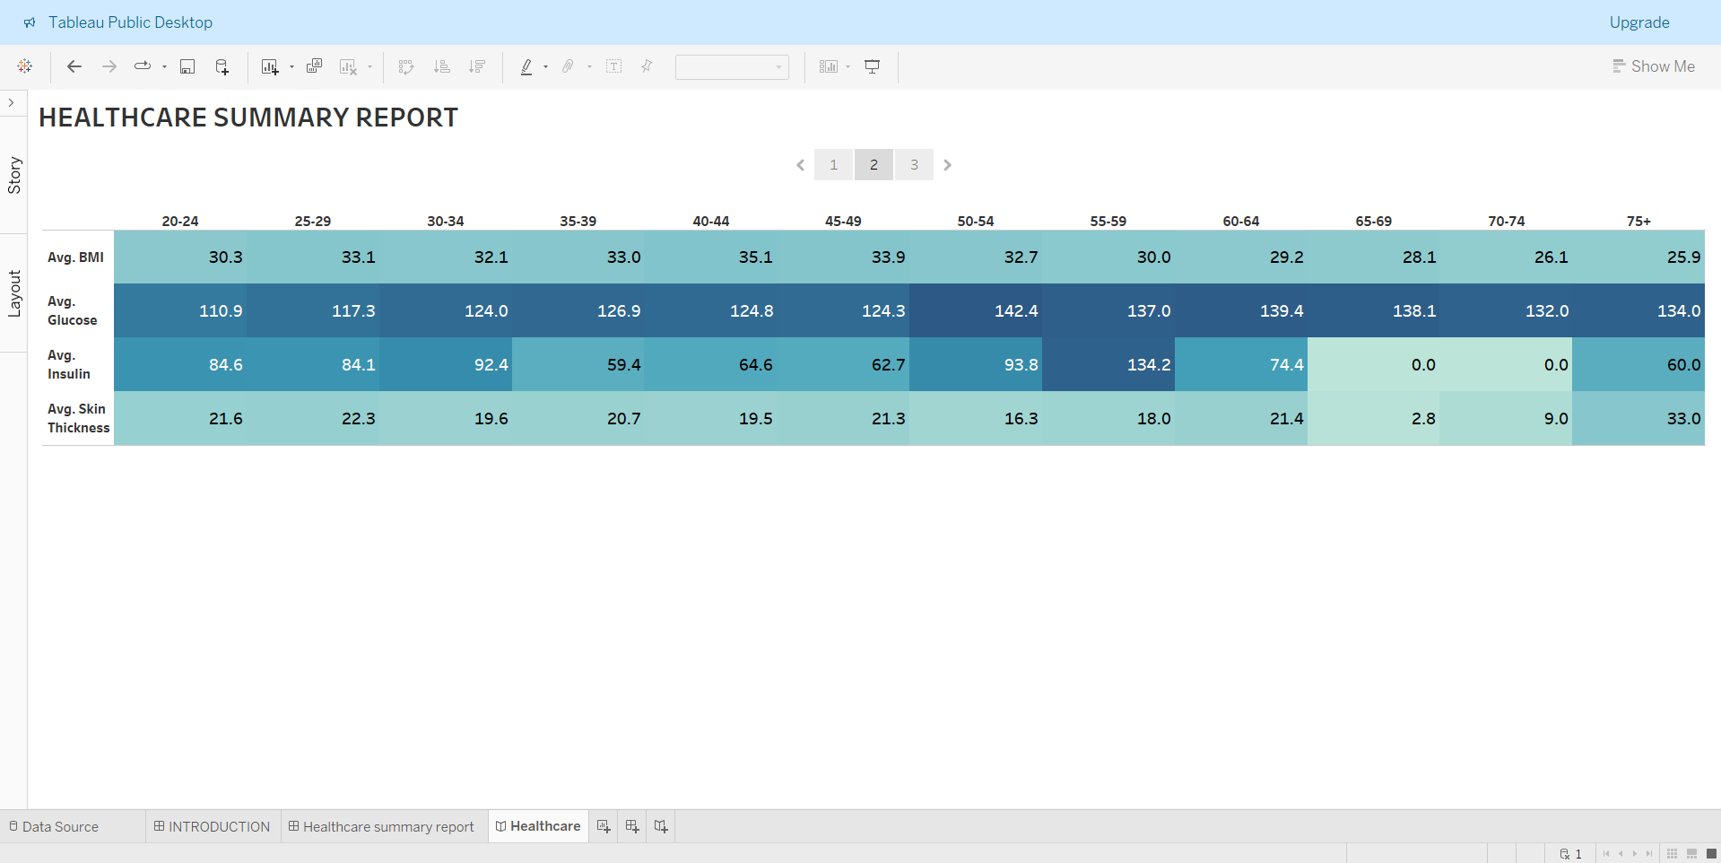

1. **View 6: Build a heat map showing several health factors by Age group**

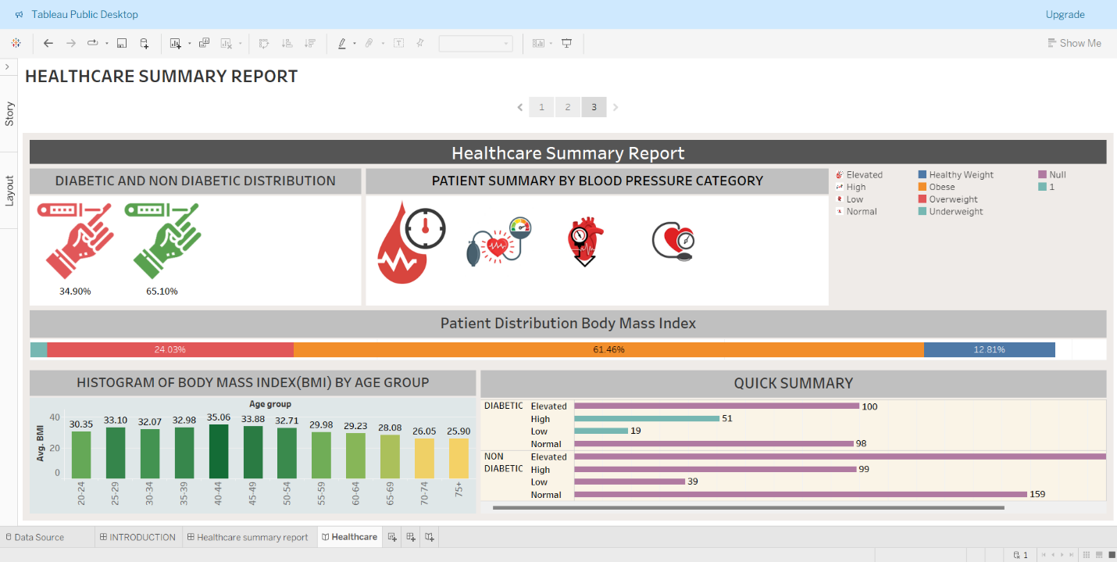

1. **Dashboard showing the overall summary of the analysis**